SER155/01

**BABCOCK UNIVERSITY**

**A TECHNICAL REPORT**

**ON**

## STUDENTS INDUSTRIAL WORK EXPERIENCE SCHEME (SIWES)

**UNDERTAKEN AT**

**V3C TECHNOLOGIES LIMITED**

**SUBMITTED TO**

**THE DEPARTMENT OF SOFTWARE ENGINEERING,**

**SCHOOL OF COMPUTING AND ENGINEERING SCIENCES BABCOCK UNIVERSITY, ILISHAN REMO OGUN STATE,**

**NIGERIA.**

**IN PARTIAL FULFILMENT OF THE REQUIREMENT FOR THE**

## AWARD OF BACHELOR OF SCIENCE DEGREE IN SOFTWARE

**ENGINEERING.**

**BY**

**KISABO RICHARD ZEYNOM**

**MATRIC. NO: 19/1078**

**SOFTWARE ENGINEERING**

**JULY, 2022**

SER155/02

# DECLARATION

This is to certify that I, KISABO RICHARD ZEYNOM, hereby declare that the information in this report was written by me. It is true that I did the Student Industrial Work Experience Scheme (SIWES) otherwise known as Industrial Training (IT) between FEBRUARY 14TH 2022 to JUNE 30TH 2022.

MATRIC: 19/1078

SIGNATURE: ______________

SIWES SUPERVISOR:______________________________

ORAL IT-DEFENSE COORDINATOR: ______________________________ SER155/03

**SIWES Class Code: SE R155**

### Student Name: KISABO RICHARD ZEYNOM

Matric. No: 19/1078

Email: kisabo1078@student.babcock.edu.ng

Level: 300

Course of study: Software Engineering

Mobile No: 08141607020

Company’s name: V3C Technologies Limited

Location: No 34 Sokode Crescent, Wuse Zone 5, Abuja

Geographical State: F.C.T

Company E-mail: info@v3ctech.com

Company’s Phone Number: 018880097

Number of Staff: 20+

Name of Industry Based Unit Head: Mr James Chinwokwu

Mobile number(supervisor): 08175845845

SER155/04

**ACKNOWLEGEMENTS**

My appreciation goes to God almighty sincerely for being with me throughout my training, His abiding knowledge and grace kept me through.

I appreciate the Industrial training fund (ITF) and the Department of Software Engineering for letting me undergo such an amazing experience.

I am grateful to V3C Technologies Limited and its supervisors for their advice, training, and tasks they rendered to me during my training.

I thank my family most especially for their care, support, and financial assistance rendered to me during my internship program.

I appreciate my industrial-based supervisors, their knowledge and skills they impacted on me, and my colleagues and friends.

I thank my Institution-based supervisors Dr. Ruth Amanze and Mr. Mayowa Osundina for taking out their time to have me inspected during my internship.

SER155/05

# TABLE OF CONTENTS

Cover page

Declaration..................................................................................................i

Student’s Profile..........................................................................................ii

Acknowlegement.........................................................................................iii

Table of Contents.........................................................................................iv

Table of Contents.........................................................................................v

# CHAPTER ONE: INTRODUCTION OF SIWES

1.1 Brief history of SIWES 08

1.2 Aims of SIWES 09

1.3 Objectives of SIWES 09

**CHAPTER TWO: COMPANY’S PROFILE**

2.1 About V3C Technologies Limited 10

2.2 Vision 10

2.3 Mission Statement 10

2.4 Services Rendered 10

2.5 Type of Clients. 10

SER155/06

## CHAPTER THREE: RESPONSIBILITIES AND PARTICIPATION

3.1 Responsibilities 11

3.2 Activities Performed 11

3.2.1 Participation at the Annual School Needs Exhibition (ASNE) 12

**CHAPTER FOUR: WORK EXPERIENCE AND KNOWLEDGE**

## GAINED

4.1 Basic Concepts of HTML/CSS 13

4.2 Basic Concepts of Networking 16

4.2.1 Network Devices 19

4.2.2 Configuring Cisco SPA 300 Series IP Phones 20

4.3 Software Installation 23

4.3.1 Installing Omada Software Controller 23

4.3.2 Installing Windows OS on MacOS Using Bootcamp Assistant 26

4.3.3 Installing FreePBX 29

4.4 Basic Concepts of Software Testing 30

4.5 **CHALLENGES FACED** 32 SER155/07

**CHAPTER FIVE: SUMMARY, RECOMMENDATION AND**

## CONCLUSION

5.1 Summary 33

5.2 Recommendation 33

5.3 Conclusion 34

SER155/08

**CHAPTER ONE**

**INTRODUCTION OF SIWES**

## 1.1 BRIEF HISTORY OF SIWES

The Industrial Training Fund (which was itself established in 1971 by decree 47) initiated the Students’ Industrial Work- experience Scheme (SIWES) in 1973. The scheme was designed to expose students to the industrial environment and enable them develop occupational competencies so that they can readily contribute their quota to national economic and technological development after graduation.

Consequently, SIWES is a planned and structured program based on stated and specific career objectives which are geared toward developing the occupational competencies of participants. In spite of the challenges faced by SIWES in the four decades of its existence, the Scheme has not only raised consciousness and increased awareness about the need for training of SET students, but has also helped in the formation of skilled and competent indigenous manpower which has been manning and managing the technological resources and industrial sectors of the economy to SET students graduating from higher institutions in Nigeria. It is therefore, not in doubt that SIWES is a veritable means or tool for

National Economic Development.

SER155/09

## 1.2 AIMS OF SIWES

SIWES is aimed at promoting the much-desired technological know-how for the advancement of the nation by exposing students to machines and equipment, professional work methods and ways of safeguarding the work area as well as the workers in industries and other organizations.

## 1.3 OBJECTIVES OF SIWES

The following are some of the objectives of SIWES:

1. To provide students the opportunity to test their interest in a particular career before permanent commitments are made.
2. To develop skills in the application of theory to practical work situations.

3. To provide students the opportunity to test their aptitude for a particular career before permanent commitments are made.

1. To develop skills and techniques directly applicable to their careers.
2. To aid students in adjusting from college to full-time employment.
3. To prepare SIWES students in entering into full-time employment in their area of specialization upon graduation.
4. To help SIWES student acquire good habits.

**CHAPTER TWO**

**COMPANY’S PROFILE**

## 2.1 ABOUT V3C TECHNOLOGIES LIMITED

V3C technologies limited is an ICT training and consultancy software company which was established on 5th November 2019 with a registered trademark of “Slate.ng” a comprehensive school management and learning platform. The company is made up with about 20 staff with different roles.

**2.2 VISION STATEMENT**

To become the leading enabler of digital school platform in Africa.

## 2.3 MISSION STATEMENT

To cultivate creativity, fosters ingenuity, and inspires a deep passion for lifelong learning and discovery.

## 2.4 SERVICES RENDERED

V3C technologies offers a wide range of services ranging from ICT training, consultancy, software development, networking, school management and learning platform.

## 2.5 TYPE OF CLIENTS

Schools, Hospitals, Government Ministries, and Private Companies.

**CHAPTER THREE**

## RESPONSIBILITIES AND PARTICIPATION 3.1 RESPONSIBLITIES

During my SIWES period at V3C technologies as an IT support, i was responsible for monitoring and maintaining my company’s computer system, also i was responsible for the installation of software on computers, I provided technical assistance with the computer hardware and software, upgrade systems to enable compatible software. I was also responsible for resolving internet connection issues. It was mandatory of me to be punctual to work, as I was given the task of arranging cables, cords, keyboards, mouses and desktops of the company.

## 3.2 ACTIVITIES PERFORMED

Some major activities performed during my internship was,

* Going to a client school to install software on their computer and ensuring everything is working perfectly.
* Going to a client hospital to provide assistance with the implementation of the clinic’s software and configuration of IP phones.
* Testing my company’s software before pushing to production.

**3.2.1 PARTICIPATION AT THE ANNUAL SCHOOL NEEDS**

## EXHIBITION (ASNE)

Annual School Needs Exhibition (ASNE) is an annual school exhibition event, this event is to bring together schools, stakeholders in edtech and the general public to come and discover the latest products and trends in education and my company happens to own a comprehensive school management system “Slate.ng”. We were part of the event which we presented our product to schools, other stakeholders and the general public.

Below is a picture of me taken at the event.



**CHAPTER FOUR**

**WORK EXPERIENCE AND KNOWLEDGE GAINED**

## 4.1 BASIC CONCEPTS OF HTML/CSS

HTML is a markup language that defines the structure of your content. HTML consists of a series of elements, which you use to enclose, or wrap, different parts of the content to make it appear a certain way, or act a certain way. The enclosing tags can make a word or image hyperlink to somewhere else,can italicize words, can make the font bigger or smaller, and so on.

<!DOCTYPE html>

<html lang="en-US">

<head>

<meta charset="utf-8" />

<meta name="viewport" content="width=device-width" />

<title>My test page</title>

</head>

<body>

<img src="images/firefox-icon.png" alt="My test image" />

</body>

</html>

* <!DOCTYPE> — doctype. It is a required preamble. In the mists of time, when HTML was young (around 1991/92), doctypes were meant to act as links to a set of rules that the HTML page had to follow to be considered good HTML, which could mean automatic error checking and other useful things. However these days, they don't do much and are basically just needed to make sure your document behaves correctly.
* <html></html> — the <html> element. This element wraps all the content on the entire page and is sometimes known as the root element. It also includes the lang attribute, setting the primary language of the document.
* <head></head> — the <head> element. This element acts as a container for all the stuff you want to include on the HTML page that isn'tthe content you are showing to your page's viewers. This includes things like keywords and a page description that you want to appear in search results, CSS to style our content, character set declarations, and more.
* <meta charset="utf-8"> — This element sets the character set your document should use to UTF-8 which includes most characters from the vast majority of written languages. Essentially, it can now handle any textual content you might put on it. There is no reason not to set this and it can help avoid some problems later on.
* <meta name="viewport" content="width=device-width"> This viewport element ensures the page renders at the width of viewport, preventing mobile browsers from rendering pages wider than the viewport and then shrinking them down.
* <title></title> — the <title> element. This sets the title of your page, which is the title that appears in the browser tab the page is loaded in. It is also used to describe the page when you bookmark/favorite it.
* <body></body> — the <body> element. This contains allthe content that you want to show to web users when they visit your page, whether that's text, images, videos, games, playable audio tracks, or whatever else.

**4.2 BASIC CONCEPTS OF NETWORKING**

## NETWORKING

Network are component involve in connecting computer and application across small and large distance.

Each computer on the network has access to the files and peripheral device (such as printers or modems) on all the other computers on the network.

## NETWORK TOPOLOGY

Common topology found in networking includes mesh topology star topology, bus topology, ring topology, and others.

Network topology refers to the layout of the transmission medium and devices on a network. Topologies use either a point to point or multipoint connection scheme.

A connection scheme indicates how many devices are connected to a

transmission media segment or an individual cable.

An example of point-to-point connection scheme is a modem/ printer connected to computer, direct cable connection between two computers.

An example of a multi-point connection scheme is a star or bus topology

network.

### Star Topology

This is a local area network topology where all the nodes are connected individually to a central connecting device called a hub or switch. Signals travel from the nodes to the hub which then sends signals to other nodes on the network. A star topology network is scale able –i.e. it can be design and

redesign easily.

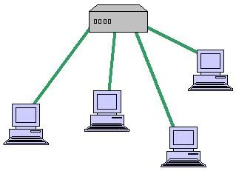

### Bus Topology

A LAN topology where each node is connected to a single main bus cable, is transmits data to all the nodes on the network. The bus is actually a series of cable segments running from one node to the other. Break or faulty piece of cable anywhere on the segment prevents all the computers on the segment from being able to communicate.

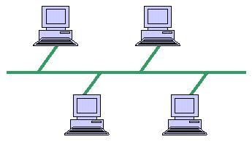

### Mesh Topology

This is a network topology where every node on the network has a separate wire connecting it to every other node on the network. It provides each device with a point-to-point connection to every other device in the network. This type of network has a high fault tolerance because failure of one node does not affect data transmission between other nodes.

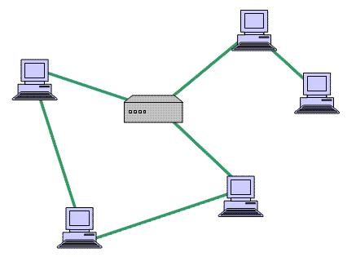

### 4.2.1 NETWORK DEVICES

#### Router

A router is a device that forwards data packets between computer networks, creating an overlay internetwork. A router is connected to two or more data lines from different networks. When a data packet comes in one of the lines, the router reads the address information in the packet to determine its ultimate destination. Then, using information in its routing table or routing policy, it directs the packet to the next network on its

journey.

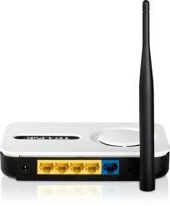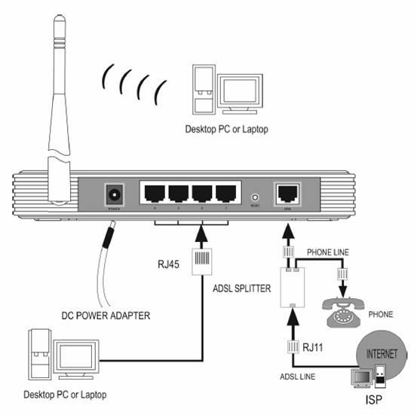

#### Switch

A network switch is a computer networking device that connects network segments or network devices. It serves mainly for extension.

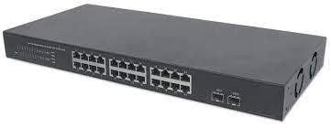

### 4.2.2 CONFIGURING CISCO SPA 300 SERIES IP PHONES

The Cisco Small Business 300 Series IP Phones are full-featured VoIP (Voice over Internet Protocol) phones that provide voice communication over an IP network. The phones provide traditional features, such as call forwarding, redialing, speed dialing, transferring calls, conference calling and accessing voice mail. Calls can be made or received with a handset, headset or over a speaker. IP phones also have special features not available in traditional phones. The Cisco Small Business 300 Series IP phones contain Ethernet ports, or ports that allow them to be linked to the computer network. They also have additional Ethernet ports that allow a computer to be connected to the network through the IP phone. Unlike traditional phones, Cisco Small Business IP phones require a separate power source. Power the phones by connecting them to the included power adapter.

Cisco SPA 300 IP Phone



#### Steps to follow when configuring

**STEP 1** Turn the phone body over to expose the ports on the back of the unit. **STEP 2** Insert the long end of the phone cord into the handset port on the phone body that is marked with a phone symbol.

**STEP 3** Insert the other end of the phone cord into the port at the bottom of the handset

**STEP 4** Connect the power by Insert one end of the power cord into an outlet and insert the other end of the power cord into the power port on the phone body.

**STEP 5** Connect phone via ethernet by Insert one end of the Ethernet cable into the network port on the phone body marked “WAN”

**STEP 6** Insert the other end of the Ethernet cable into the appropriate device, such as a network switch, on your network.

In general, to connect a headset. connect the 2.5mm connector from the headset into the headset port on the right side of the IP phone.

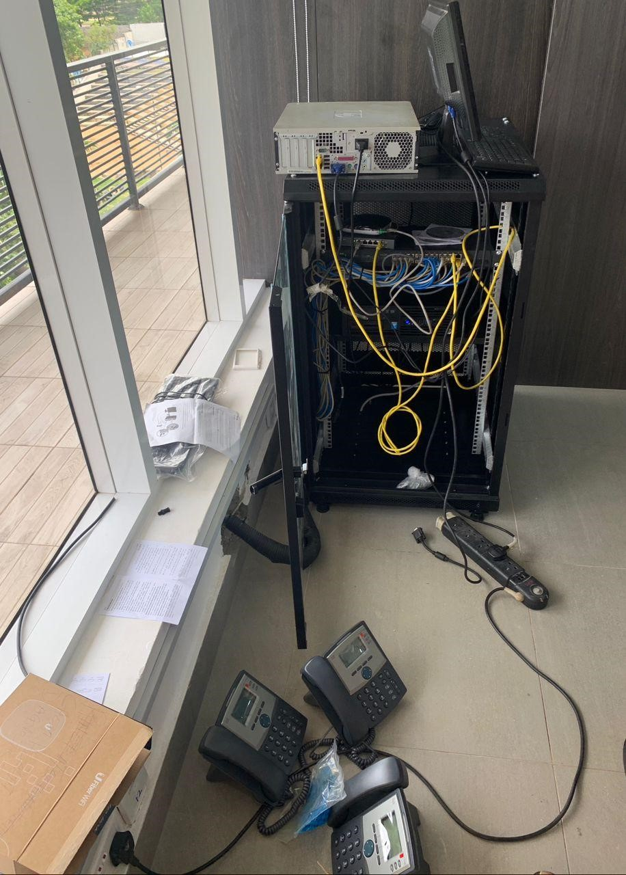

Configuring Cisco IP Phone at a client’s hospital.

## 4.3 INSTALLING SOFTWARE

Software installation (or setup) of a computer program (including device drivers and plugins), is the act of making the program ready for execution. Because the process varies for each program and each computer, programs (including operating systems) often come with an installer, a specialized program responsible for doing whatever is needed for t heir installation. Installation may be part of a larger software deployment process.

### 4.3.1 INSTALLING OMADA SOFTWARE CONTROLLER

One of my task during my internship was to install the Omada Software Controller. This is a management software for TP-link EAP devices with this software you can use a web browser to centrally manage your EAP devices such as configured EAPs in batches and conduct real-time monitoring of EAPs.

Steps in setting up the Omada Software Controller.

**STEP 1** Downloaded the software from their official website

“www.tp-link.com”

**STEP 2** Installed and initialized the software.

**STEP 3** Name your controller, select the country or region, and your timezone. Choose one of the scenario that make sense to your application. Then click on the Next.

**STEP 4** The controller will discover all the devices connected. Select all devices and then click on the Next.

**STEP 5** Enter the wireless ID (SSID) and password and then click on Next

**STEP 6** Enter the administrator name. This administrator name is different and not related to the cloud account ID. You can use this credential to access the controller directly when you have the local access. The email address is for notifications. You have to setup the SMTP server later to enable the email notification. Enter all the information and then click on the Next button.

**STEP 7** Review all the settings and then click on the Finish. If you want to change the settings, click on the Back button.

**STEP 8** The system setup is done by now. You can then click through the overview to get familiar with the user interface.

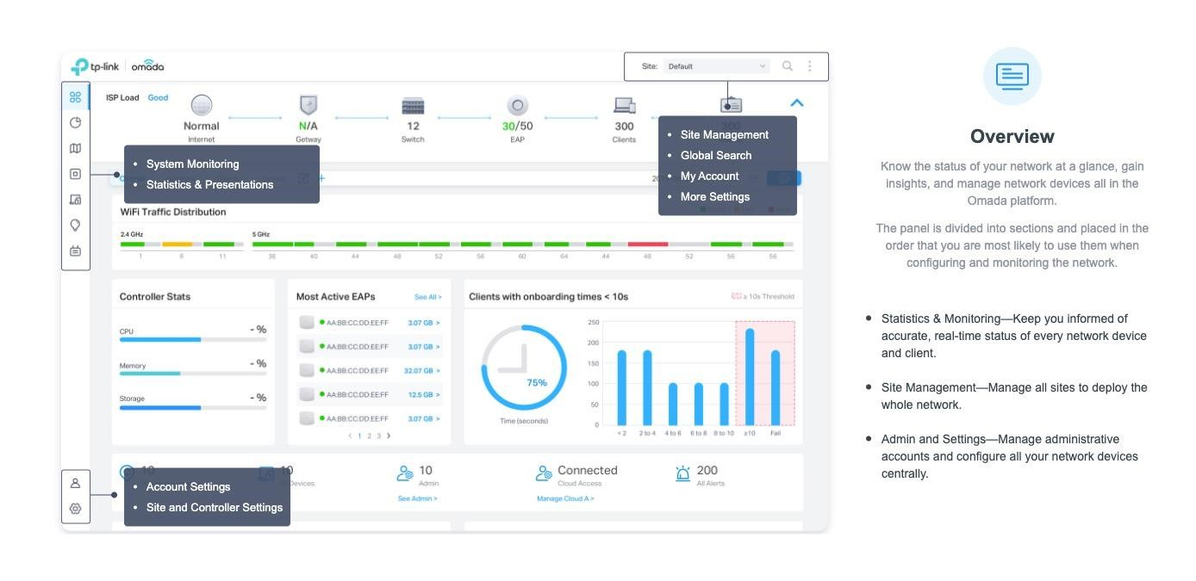

The Omada Software Controller Dashboard.

**4.3.2 INSTALLING WINDOWS OS ON MACOS USING BOOTCAMP**

## ASSISTANT

If you wish to run both macOS and Windows on a single Mac computer, using Apple’s Boot Camp Assistant will help you partition your Mac’s hard drive to accommodate both operating systems, so you can install Windows from an installation disk or an ISO image stored on a flash drive or on your Mac

computer.

Requirements for installing Windows 10 on MAC.

● At least 80GB of free hard drive space.

● Have a USB flash drive of at least 16GB and above.

● Ensure that the computer is plugged into a power source, as the entire process may take several hours.

Installation Guide.

**STEP 1.** Download Windows 10.

Go to www.microsoft.com to download the windows 10 ISO file.

**STEP 2** Use Boot Camp Assistant to create a windows partition.

Open Boot Camp Assistant, which is in the utilities folder of your applications

folder.

Follow the onscreen instructions.

* If you are asked to insert a USB drive, plug your USB flash drive into your

Mac.

Boot Camp Assistant will use it to create a bootable USB drive for installation. NOTE. It is very important that you back up your USB flash drive if you haven’t done so. By creating a bootable USB drive, Boot Camp Assistant may erase the entire

contents.

* When Boot Camp Assistant asks you to set the size of the Windows partition, set a partition size that meets your needs, because you can’t change its size later.

**STEP 3.** Format the Windows(Boot Camp) Partition.

When Boot Camp Assistant finishes, your Mac restarts to the Windows

installer.

If the installer asks where to install windows, select the Boot Camp partition and click format.

**STEP 4**. Install Windows.

Unplug any external devices that aren’t necessary during installation. Then click NEXT and follow the onscreen instructions to begin installing windows. The

installer

will copy Windows files and install any features and updates required. When prompted, click RESTART NOW to restart your computer.

**STEP 5.** Configure Windows 10.

After Windows restarts, you will need to do some configuration by selecting,

* Your appropriate region.
* The keyboard layout
* And then connecting to a network.

**STEP 6.** Create Your Windows Administration Account.

* To create your account, type your name and click NEXT.
* Type a password and click NEXT.
* Confirm your password by typing it again and clicking NEXT.
* Select a series of three security questions by clicking NEXT after each one.

Windows will do its final configurations. The step may take some time.

**STEP 7.** Use the Boot Camp Installer in Windows to Install Support Software.

* To begin the process click NEXT.
* Read and accept the license agreement and click Install. All the Apple Specific Software you need to run windows efficiently on your computer will be

installed.

* When the installer finishes, click Finish.
* To restart the computer, click YES.
* When the computer restarts, your installation has been completed successfully.

HOW TO SWITCH BETWEEN WINDOWS AND MACOS.

Restart, then press and hold the Option or Alt key during startup to switch between

Windows and macOS.

### 4.3.3 INSTALLING FREEPBX

FreePBX is an open-source solution and web-based graphical user interface (GUI) for managing and controlling the open source communication server –

Asterisk (PBX).

Steps in installing FreePBX

1. Download the ISO file to bootable USB drive
2. In its BIOS menu, configure the computer that will serve as your FreePBX server to boot from a drive
3. Insert the drive into the computer and turn it on.
4. Follow the FreePBX system prompts as it installs and restarts the computer.
5. After installation is complete, enter the IP address of the new PBX into a web browser on the same network. This will allow you to create the admin username and password.
6. Configure your new IP PBX!

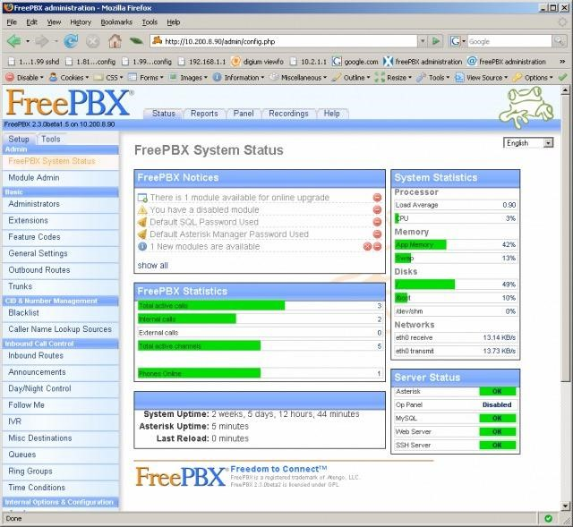

## 4.4 BASIC CONCEPTS OF SOFTWARE TESTING

During my internship, I was introduced to the concept of software testing. Software Testing is a method to check whether the actual software product matches expected requirements and to ensure that software product is Defect free. It involves execution of software/system components using manual or automated tools to evaluate one or more properties of interest. The purpose of software testing is to identify errors, gaps or missing requirements in contrast to actual requirements.

**Why Software Testing is Important?**

Software Testing is Important because if there are any bugs or errors in the software, it can be identified early and can be solved before delivery of the software product. Properly tested software product ensures reliability, security and high performance which further results in time saving, cost effectiveness and customer satisfaction.

**Types of Testing**

### Unit Testing

It focuses on the smallest unit of software design. In this, we test an individual unit or group of interrelated units. It is often done by the programmer by using sample input and observing its corresponding outputs.

Example:

a) In a program we are checking if the loop, method, or function is working

fine.

### Integration Testing

The objective is to take unit-tested components and build a program structure that has been dictated by design. Integration testing is testing in which a group of components is combined to produce output.

Example:

1. Black Box testing:- It is used for validation. In this, we ignore internal working mechanisms and focus on what is the output?.
2. White box testing:- It is used for verification.

In this, we focus on internal mechanisms i.e. how the output is achieved?

### System Testing

This software is tested such that it works fine for the different operating systems. It is covered under the black box testing technique. In this, we just focus on the required input and output without focusing on internal working. In this, we have security testing, recovery testing, stress testing, and performance testing

Example:

This includes functional as well as nonfunctional

Testing.

## 4.5 CHALLENGES FACED

1. During my first few weeks, I had difficulties understanding a lot of the terms and terminologies that was used at the office because a lot of them were very new to me. This made it difficult to follow the procedures at first.
2. The cost of transportation for each week was much and the cost in transportation always varies due to weather and certain days.

**CHAPTER FIVE**

**SUMMARY, RECOMMENDATION AND CONCLUSION**

## 5.1 SUMMARY

The gains of this exercise are immense; that it was worth the while is grossly an understatement. Being accorded another opportunity in life to be exposed to the rudiments of work places outside the class room teaching is an experience of a

life time.

Furthermore, the exposure to practical tools, software and hardware had engendered better understanding of lessons thought in the class room

## 5.2 RECOMMENDATION

Some recommendations for future improvement of the scheme;

* Organizing workshops, seminars and symposium for students in various faculties in other to keep the student abreast of new technologies and

innovations.

* Posting of students for SIWES should be done by the scheme to ensure

conformity with course of study.

* A mass enlightenment campaign should be carried out, to enable industries and establishments know the importance of SIWES to the future of the student and the society at large.
* The scheme should also try to enforce the act guiding the establishment of the scheme, to serve as deterrent to those establishments who reject student for IT.
* School Curriculum should be organized in such a way that the SIWES exercise be carried out at a stretch of six months and not the intermittent arrangement of three months twice.

## 5.3 CONCLUSION

The Student Industrial Work Experience Scheme (SIWES) plays a significant role in human resource development, it helps students develop new skills and enlightens them of what the present society holds for them after graduation and helps them adapt accordingly.